PH126 Logic I Lecture 12
Lecturer: s.butterfill@warwick.ac.uk
Quantifier Recap
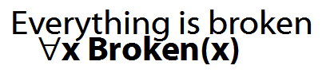
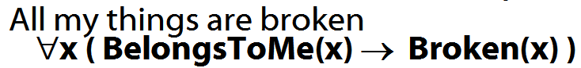
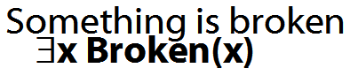
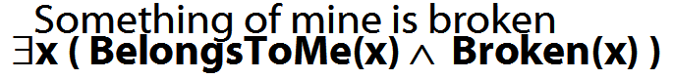
How to determine truth of a sentence with an existential quantifier as the main connective
1. Give every object a name.
2. For each name in turn, create a new sentence like this: delete the quantifier and replace all instances of the variable it binds with that name
3. If ANY OF the new sentences are true, so is the original.

How to determine truth of a sentence with a universal quantifier as the main connective
1. Give every object a name.
2. For each name in turn, create a new sentence like this: delete the quantifier and replace all instances of the variable it binds with that name
3. If ALL OF the new sentences are true, so is the original.
Multiple quantifiers
‘There is a store for everything’
∃y∀x StoreFor(y,x)
∀y∃x StoreFor(x,y)
Other sentences to translate:
‘Wikipedia has an article about everything’
‘Everyone hurts someone they love’
‘Someone hurts everyone she loves’

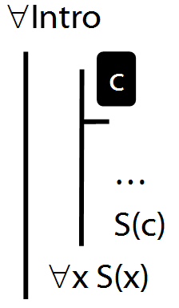

∀Intro Example proof
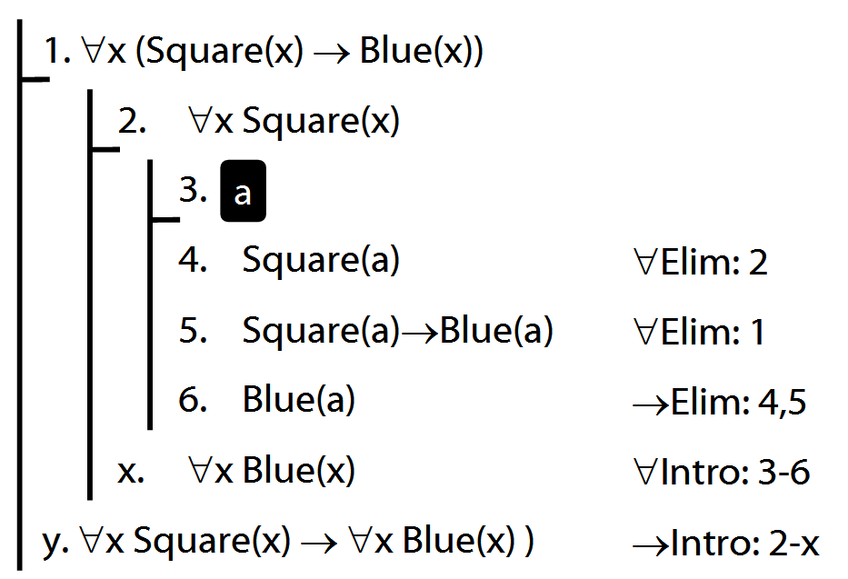
Why is this proof incorrect?
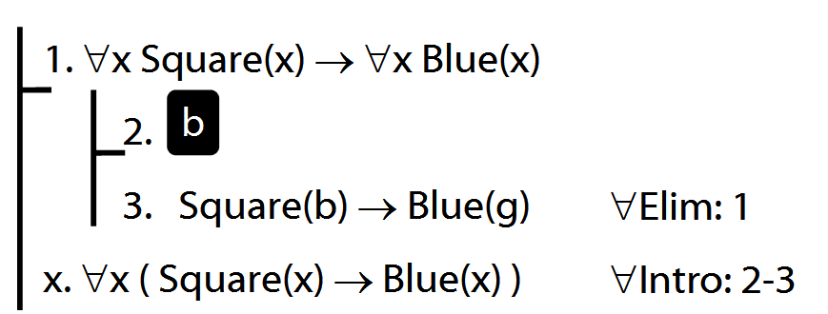

Intuitve summary of quantifier rules
